External Referencing and
Benchmarking Plan

Address: Level 4, 303 Collins Street Melbourne VIC 3000
Phone: +61 3 8648 6610 | Email: admin@lyons.edu.au | Website: www.lyons.edu.au
CRICOS Provider No: 03578M | RTO Code: 21986

Introduction

The External Referencing and Benchmarking Plan was developed to support the Lyons College Strategic Plan 2020-2024 which sets the overall direction of Lyons College as a provider of quality vocational education and training (VET) and higher education (HE) courses. The Strategic Plan includes Lyons College’s Vision, Mission, Values, Strategic Objectives and Strategic Goals (as summarised in the diagram below). This plan should be read in conjunction with the External Referencing and Benchmarking Policy.

This Plan outlines the external referencing that has been and will be conducted to support the development and ongoing monitoring, review and continuous improvement of the following areas:

- Workforce Plan;
- Program design, development and ongoing monitoring and review of program outcomes;
- Policies and Procedures;
- Learning and Teaching Plan; and
- Expert independent advice to committees and governing boards including Board of Directors, Academic Board, Teaching and Learning Committee.
Figure 1: External Referencing and Benchmarking Plan supporting strategy and business plan.
- Figure 1

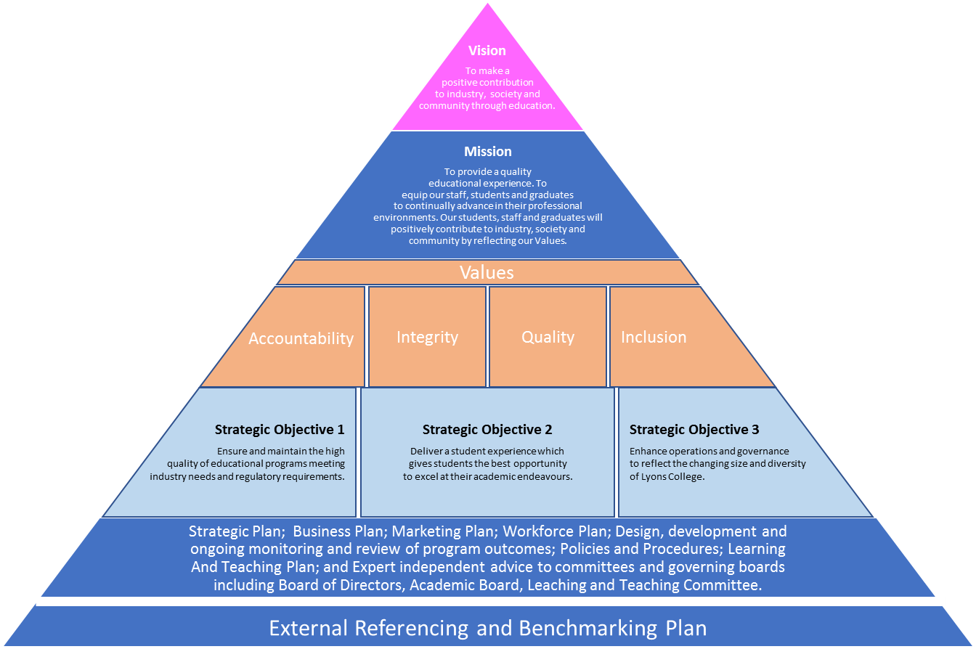

Lyons College recognises that successful higher education delivery depends on differentiating Lyons College’s educational offerings in the marketplace to inform and engage students, employers and staff, while demonstrating both quality and relevance of course offerings.

Lyons College is committed to using external referencing and benchmarking as a quality process integral to corporate and academic governance processes. External referencing and benchmarking activities assist Lyons College shape its strategic and operational planning, review its operations and leverage external expertise and inputs in identifying strengths, weaknesses and best practice to inform continuous improvement. This plan establishes a rationale, framework and scope for Lyons College’s approach to external referencing and benchmarking activities. It also supports the Higher Education Standards Framework (Threshold Standards) 2015 concerning:
- Institutional Quality Assurance – monitoring, review and improvement at Standards 5.3.1, 5.3.4 and 5.3.7 and
- The specification of learning outcomes at Standards 1.4.1, 1.4.3 and 1.4.4

The key elements of this plan are outlined below. Lyons College will:

- Elicit appropriate external input through Membership of the Council of Private Higher Education (COPHE)
- Appoint expert independent advisors to committees and governance entities
- Undertake regular external review and benchmarking

Member of Council of Private Higher Education (COPHE)

COPHE is a peak body representing Australian private higher education institutions. Lyons College is currently an Associate Member with COPHE and enjoys the benefits of full COPHE membership with the exception of being able to vote at the COPE Annual General Meeting. Upon gaining approval from TEQSA as a Higher Education Provider, Lyons College will immediately convert from Associate Member to Member of COPHE.
As an Associate Member of COPHE Lyons College has access to the following, many of which support Lyons College with its external referencing and benchmarking activities:
- Access to Higher Education reports and benchmarking (such as Quality Indicators for Learning and Teaching)
- Participating in benchmarking with other COPHE members
- Access to training, such as Sexual Harassment training offered free of charge to COPHE members
- Access to COPHE seminars and sessions to discuss issues and good practices in Higher Education
- Access to COPHE support and services such as independent mediation
- Access to library resources if required at an additional cost

Lyons College has referenced the 2017 Student Experience Survey National Report, Quality Indicators for Learning and Teaching (QILT), shared by COPHE (https://www.qilt.edu.au/docs/default-source/ues-national-report/2017-student-experience-survey-national-report/2017-ses-national-reportb27e8791b1e86477b58fff00006709da.pdf?sfvrsn=1e96e33c_2) covering the following areas:
- Skills Development;
- Learner Engagement;
- Teaching Quality;
- Student Support; and
- Learning Resources.

The Report provided valuable insights from an external perspective that have informed Lyons College’s strategy, plans, policies and procedures. This Report was also tabled and discussed at the Board of Directors and Academic Board July 2018 meetings. Accordingly, it has informed Lyons College’s approach to managing and measuring:
- Student attrition, by better understanding the drivers of undergraduate students to consider early departure (page 29) and
- Student experience – the report provides valuable insights into the different aspects of student experience – appendices 2 and 3 have been used as input to the development of a student questionnaire tailored to Lyons College.

Lyons College will also consider other published reports as a source of external referencing (for example reports released by the Department of Education and Training).

Expert independent advice to committees and governing boards

Independent external experts provide external referencing and independent advice to Lyons College’s key committees and governing boards including:
- Board of Directors;
- Academic Board;
- Course Advisory Committee;
- Audit and Risk Committee; and
- Learning and Teaching Committee.

Lyons College has conducted various external referencing and benchmarking work throughout 2016 to 2018 (refer appendix 1). In addition to the independent external experts who inform these committees and boards, a panel of independent Higher Education experts have been approved by the Board of Directors to further assist in external referencing or benchmarking activities as outlined in this plan, as per below. All of these experts have provided specific external referencing and advice in accordance with their area of specialisation throughout 2016 to 2018 and will be called upon on an as-required basis going forward.

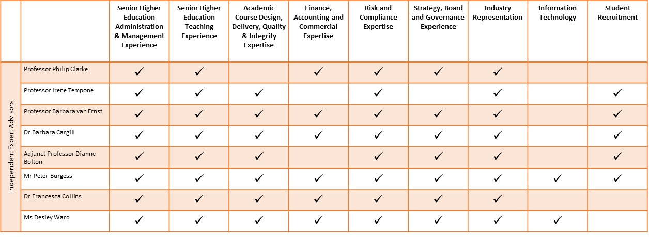

Regular external review and benchmarking

In addition to ongoing COPHE membership, Lyons College is also registered and will use the Peer Review Portal as part of its external review and benchmarking of its program. Lyons College has engaged with Dr. Sara Booth, an expert in HE benchmarking at the University of Tasmania, to establish a framework for ongoing external review and benchmarking, to be conducted on an annual basis, at a minimum. The use of the Peer Review Portal as an ongoing tool for external review has been discussed at the Board of Directors and Academic Board meetings in July 2018 and has been selected because it is used by more than 152 registered Higher Education providers.

On at least an annual basis Lyons College will use the Peer Review Portal to conduct benchmarking on the following:
- Course design
- Methods of assessment
- Student achievement of learning outcomes

Also, external referencing will be conducted on a regular and as-required basis for the moderation of student marks from assessments.

The Australian University Teaching Criteria and Standards Framework (http://uniteachingcriteria.edu.au/) has been used in the development of the Workforce Plan and Learning & Teaching Plan. On an at least annual basis Lyons College will review the Workforce Plan and Learning & Teaching Plan and update it as required based on:
- Student and staff survey results
- Updates/improvements to the Australian University Teaching Criteria and Standards Framework.

The results of the annual external review and benchmarking will be provided to the Board of Directors and Academic Board for review. Students will also be annually surveyed for internal benchmarking and trend analysis and data provided to the Board of Directors and Academic Board. The following areas will be included in the student survey to be conducted at least on an annual basis:
- Skills Development;
- Learner Engagement;
- Teaching Quality;
- Student Support;
- Learning Resources; and
- Course experience.

Similarly, staff will be surveyed at least on an annual basis covering the following areas:
- Staff professional development;
- Staff satisfaction regarding support and resources; and
- Overall staff satisfaction and recommended areas for improvements.

In summary, the following areas will be reviewed at least on an annual basis with external referencing (and benchmarking as required):

1. Library resources Benchmarking

Library resources, including learning environment, support and access to databases.

2. Computer and other technology to support learning Benchmarking

Computer resources, including access to equipment, wi-fi and the quality of technical support

3. Student Study Support Benchmarking

Support for student study including resources, orientation, staff availability, skills workshops.

4. Course Benchmarking

Course design and external course reviews processes.

5. Policies Benchmarking

A broad range of College policies including those around course design and development, student assessments, etc. will be externally reviewed using the Peer Review Portal. Policies will also be externally reviewed by independent Higher Education experts to ensure they are consistent with the Higher Education Standards Framework and remain current.

6. Independent expert review of the effectiveness of the Board of Directors and Academic Board
In line with the Board of Directors and Academic Board terms of reference documents, independent experts will be engaged to review the effectiveness of the Board of Directors and Academic Board on a regular basis.

Appendix 1 – Summary of External Referencing work conducted to-date

In addition to the ongoing input from independent external experts as part of their involvement with the Academic Board, Course Advisory Committee, Audit and Risk Committee and Learning and Teaching Committee, Lyons College has conducted various external referencing and benchmarking work throughout 2016 to 2018.

Foundation External Referencing and Benchmarking – Bachelor of Accounting

Initially the design of Lyons College’s proposed degree of Bachelor of Accounting benefitted from a benchmarking exercise of accounting degrees and majors across universities including those from the Group of Eight (go8) other universities and private providers. Refer to Course Proposal for details.

Data was collected on Australian National University (ANU), University of Western Australia (UWA), University of Adelaide (UA), Swinburne University of Technology (SUT), La Trobe University, Western Sydney University (WSU), Queensland University of Technology (QUT), Charles Sturt University (CSU), Central Queensland University (CQU), Australian Catholic University (ACU), Victoria University (VU) (added subsequently), Kaplan Business School (KBS), Holmesglen Institute (HI) and Melbourne Institute of Technology (MIT).

As can be seen in Appendix 1 of the Course Proposal, the initial purpose was to understand the market in terms of Admissions Policy including Entry Requirements (including English Language requirements), fees, length of course, scholarships, deferral and withdrawal arrangements, delivery methods and semester structure. A second level of analysis considered the relationship between course design, graduate attributes and employability.

This initial review allowed a preliminary conceptualisation of the relationship between brand, price, admission criteria, graduate attributes and perceptions of employability, comparing go8 members, other universities with lower admission criteria and price and private providers.

A later stage of review focussed more on positioning offerings through course design and related curriculum.

External referencing and benchmarking as an aid to strategic positioning: Reflections on the development of value and brand (2016-18).

Figures 1 & 2 below, presents visually the purported relationships between key factors that were identified from the initial benchmarking exercise. Figure 1 suggests that there is a relationship between admission criteria and fees and these will increase as brand is developed in the market. Lyons College wanted to be seen as occupying a mid-space in the market; admission criteria require an ATAR score of 60 and an IELTS score of at least 6.5 with no band less than 6.0, or an equivalent score on an alternative English test such as Test of English as a Foreign Language (TOEFL), Pearson Test of English (PTE), Cambridge English: Advances (CAE) and Test of English for International Communications (TOEIC). The test result must not be older than 12 months from date of course commencement. Refer to Course proposal for details.

This level of student capability would cope successfully with a degree designed to foster critical and adaptive skillsets and attributes relevant to students being able to take advantage of dynamic technological shifts in the profession, and create client value through nuanced and customised client support. Figure 1 also reflects that benchmarking data demonstrates the association between increased admission criteria and higher fees. This conclusion poses the challenge of creating a brand that reflects a value set, attractive across stakeholders in a dynamic business and professional environment.

Figure 2 demonstrates the initial aspiration of Lyons College regarding the shaping of unique graduate attributes through an accounting degree that develops soft skills around client/stakeholder engagement. Such skills are seen as essential in fast moving environments characterised by technological shifts, requiring professional adaptation to leverage opportunities for increased client engagement in service design and delivery. These learning outcomes were also seen as being reflected in desirable graduate attributes to allow graduate capability to respond to a changing environment, in turn enhancing employability and shaping perceptions of value and ultimately desirable brand.

When Figure 2 is overlaid on Figure 1, the aspirational positioning and the existing perception of brand are not aligned. It was anticipated that Lyons College would further develop its aspirational positioning to build brand. A strategy based on graduate attributes and employability as a basis for brand allowed for further decisions to be made about relevance of the degree design to differentiate Lyons College further from both the lower and middle level university providers and private providers of higher education.

At a later stage (Figure 3) further analysis of possible differentiation in the market suggested that more consideration be given to the design of the degree as a basis of competitive advantage. Benchmarked institutions were considered as points of reference as to whether and how the degree might have an enhanced focus on the finance market to increase the value of graduate attributes in the marketplace. Program offerings of RMIT, SCU and UNE were reviewed, to consider the integration of the Accounting, Finance and Business units, to achieve a unique market offering as detailed in the Program Proposal.

The linear process of analysis of this initial benchmarking exercise, influenced by other publications and external expert commentary is presented visually below.

